DIGITAL COMMUNICATION SYSTEM

PROJECT REPORT

CIS TE (BATCH 2017)

Car Number Plate Detection Using Image Processing

It is a vehicle's number/license plate recognition program based on the very elementary technique of Templates matching. The algorithm takes an input image of the number plate (number plate should be dominant in the image) and after filtering the image, it performs region based operations. Then it tries to capture through matching outputs the string of number plate characters.

MEMBERS:
- MIDHAT UROOJ (CS-039)
- AREEBA SEHER (CS-063)

WHAT IS IMAGE PROCESSING?
Image processing is a method to perform some operations on an image, in order to get an enhanced image or to extract some useful information from it. It is a type of signal processing in which input is an image and output may be image or characteristics/features associated with that image. Nowadays, image processing is among rapidly growing technologies. It forms core research area within engineering and computer science disciplines too.
Image processing basically includes the following three steps:
- Importing the image via image acquisition tools;
- Analysing and manipulating the image;
- Output in which result can be altered image or report that is based on image analysis.
There are two types of methods used for image processing namely, analogue and digital image processing. Analogue image processing can be used for the hard copies like printouts and photographs. Image analysts use various fundamentals of interpretation while using these visual techniques. Digital image processing techniques help in manipulation of the digital images by using computers. The three general phases that all types of data have to undergo while using digital technique are pre-processing, enhancement, and display, information extraction.

HOW DOES IT WORK?
- Design Process
The design of the algorithm follows the below given steps. The successful execution of all steps gives the characters of the number plate in crop form. The steps are capturing input image, extract Y component, noise removal, dilation morphology, vertical edge processing, horizontal edge processing, segmentation, number plate extraction, character extraction, character matching and character display in crop image form. 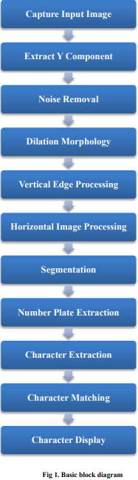

- Methodology
First, the image is captured through image capturing devices and then fed to the system for conversion of color image into gray scale image. If the image which is fed in the system is a colored image which is represented by 3D array in MATLAB, it is converted to a 2D gray scale image before it is further used for processing. Using dilation, the noise present in the image is removed which sharpens the edges and hence increases the difference of gray value between the neighboring pixels at the edge of an object which will enhance the edge detection. The next step includes detecting rectangular shaped number plate and its extraction using Prediction based algorithm. We partition the number plate into objects/regions for extraction of characters. Finally, the characters of number plate are extracted, matched and displayed.

- Converting a colored image into grey image
The used algorithm uses a grey scale image for processing; hence, the first step is to convert a colored image into a grey image. It is accomplished by a function called rgbtogrey(image). This function converts the colored metal from represented as 3D array to grey image represented as a 2D array
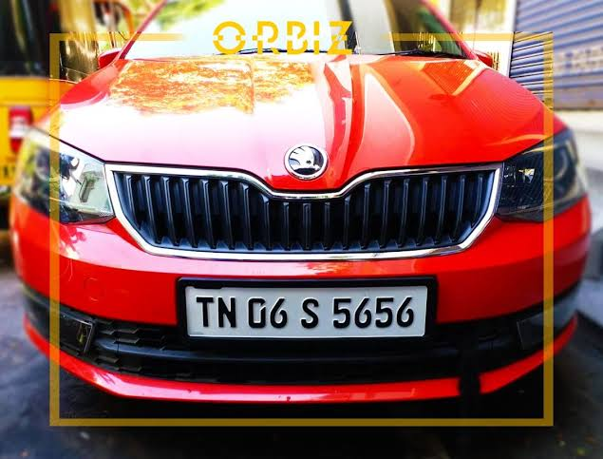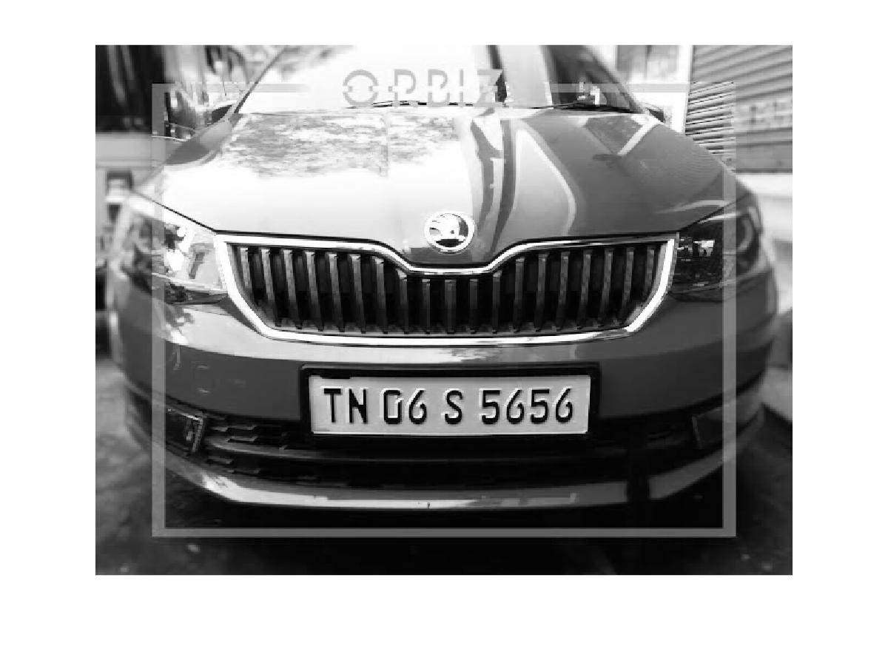

- Dilation of image
Dilation is a process of improving an image by filling holes in an image, sharpening of edges of objects in image, joining of broken lines, increasing the brightness of image and removal of noise within image. Sharpening of edges increases the difference between neighboring pixels, hence increasing edge detection. During converting to grey images the difference in color, lighter edges of objects etc. can get lost. Dilation of image helps in nullifying these losses.

- Horizontal and vertical edge processing
Horizontal and Vertical Edge processing is done, which is represented by column-wise and row-wise histogram respectively. The given histograms basically shows the sum of differences of grey values between neighboring pixels of an image, column and row- wise. In order to find the horizontal histogram, the algorithm traverses the picture through each of the column. In each column, the second pixel from top gets selected and its difference with the first pixel is calculated. It is added to the total sum of differences of values, if the difference exceeds the defined threshold. Then the difference between the third and second pixel is calculated and so on. This is carried on throughout the image. The same process is carried out vertically for vertical edge processing.

- Passing the histogram through a low pass digital filter
As we see that the histogram values change hugely between consecutive rows and columns. Thus, to eliminate the loss of important information in further steps, it is better to smooth out these changes in values of histogram. So to achieve this purpose, the histogram is passed through a low pass digital filter. The filter averages out each histogram value considering the values on its right-hand side and left-hand side on both horizontal and vertical histograms.
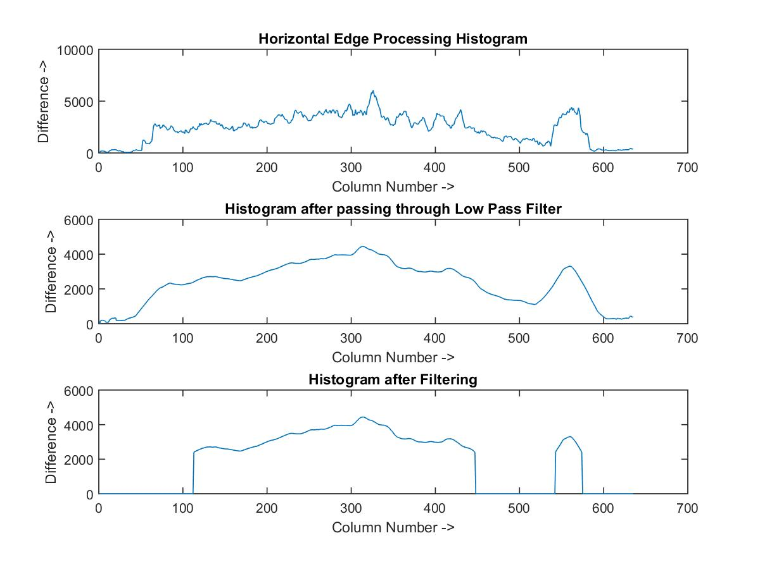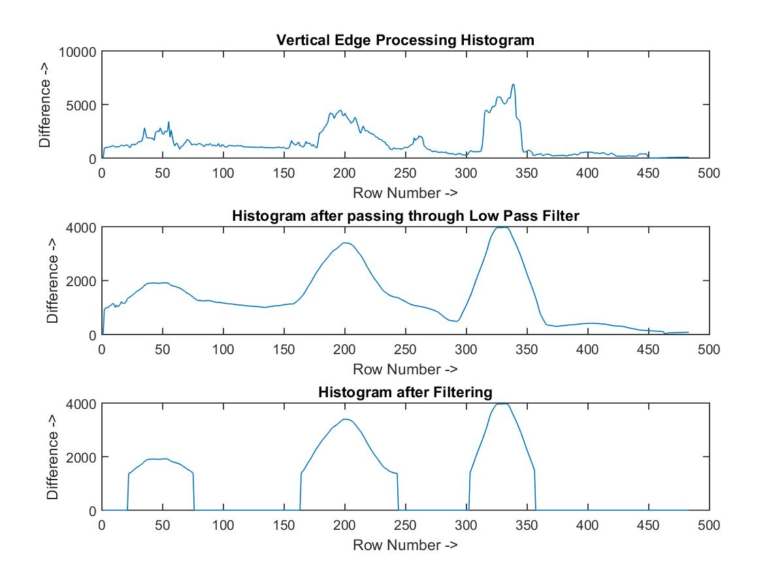
- Filtering out unwanted regions in an image
The unwanted areas from an image is removed using a filter. We consider the unwanted areas as the regions having low histogram values. Removal of such regions is done by applying dynamic threshold.

- Segmentation
All the regions in image having high probability of containing a license plate is found by doing segmentation. In this process the co-ordinates of all such probable regions are taken and is stored in an array. The most probabilistic regions of number plate is shown by output image.
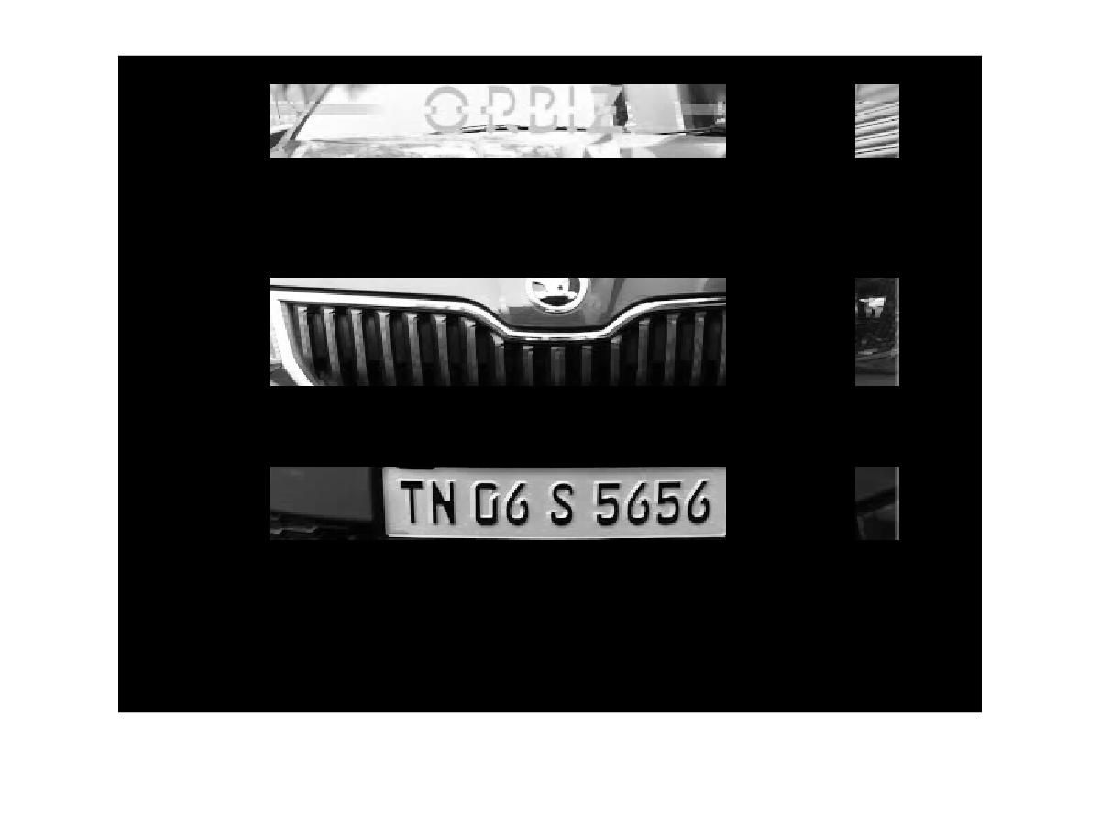
9.Prediction of region containing number plate/ Extraction of region of interest

From all the regions having the most probability of having the number plate, the one which is having maximum histogram value is considered as the most probable candidate for the number plate detection. To find common maximum horizontal and vertical histogram value containing region all regions are processed row and column wise. That is the region, which is predicted to contain the number plate
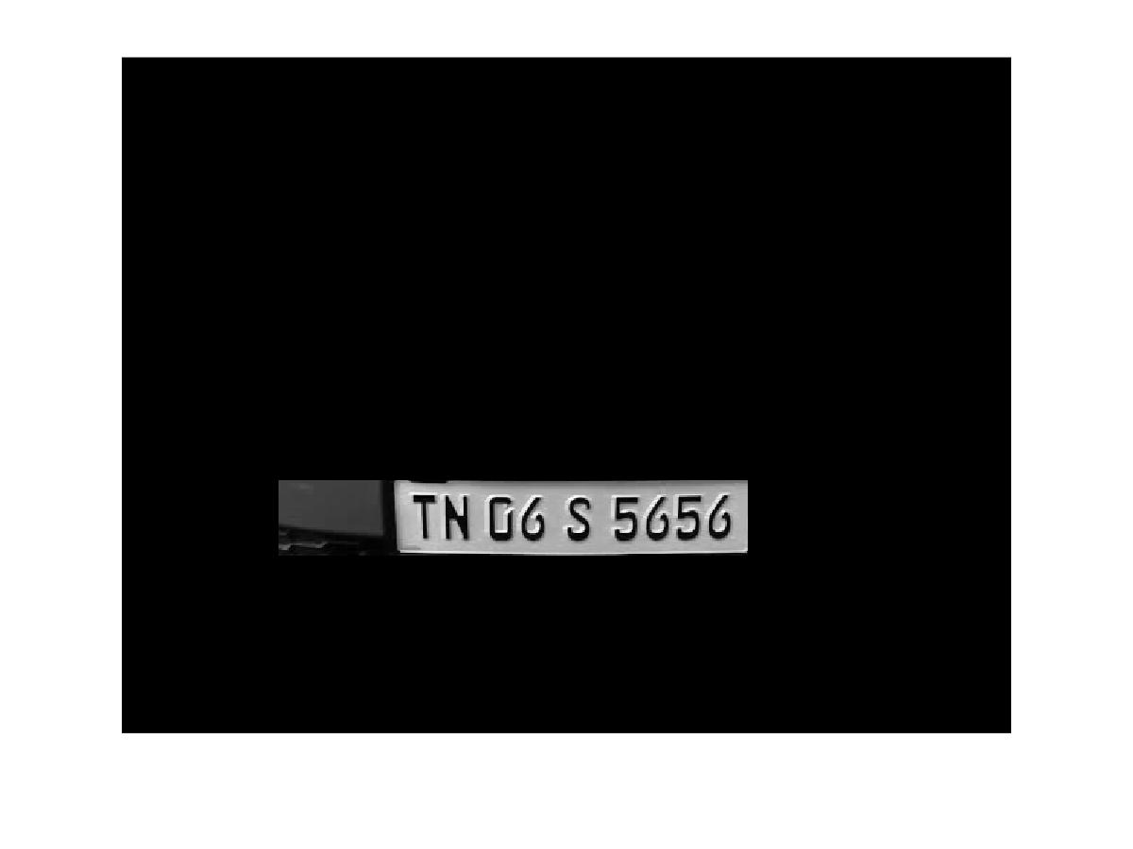

10.FUTURE SCOPE
This project can extract number plate of vehicle from an image of the vehicle. Since prediction-based extraction works based on prediction of position of number plate in the image there is always some scope of improvement in the accuracy of prediction made by the algorithm.
11.CODE
clc;
clear all;
close all;
I = imread ('car.jpg');
figure(1);
imshow(I);
Igray = rgb2gray(I); %(Convert an Image to Gray)
[rows cols] = size(Igray);
Idilate = Igray; %% Dilate and Erode Image in order to remove noise
for i = 1:rows
for j = 2:cols-1
temp = max(Igray(i,j-1), Igray(i,j));
Idilate(i,j) = max(temp, Igray(i,j+1));
end
end
I = Idilate;
figure(2);
imshow(Igray);
figure(3);
title('Dilated Image')
imshow(Idilate);
difference = 0;
sum = 0;
total_sum = 0;
difference = uint32(difference);
%% PROCESS EDGES IN HORIZONTAL DIRECTION
max_horz = 0;
maximum = 0;
for i = 2:cols
sum = 0;
for j = 2:rows
if(I(j, i) > I(j-1, i))
difference = uint32(I(j, i) - I(j-1, i));
else
difference = uint32(I(j-1, i) - I(j, i));
end
if(difference > 20)
sum = sum + difference;
end
end
horz1(i) = sum;
% Find Peak Value
if(sum > maximum)
max_horz = i;
maximum = sum;
end
total_sum = total_sum + sum;
end
average = total_sum / cols;
figure(4);
% Plot the Histogram for analysis
subplot(3,1,1);
plot (horz1);
title('Horizontal Edge Processing Histogram');
xlabel('Column Number ->');
ylabel('Difference ->');
%% Smoothen the Horizontal Histogram by applying Low Pass Filter
sum = 0;
horz = horz1;
for i = 21:(cols-21)
sum = 0;
for j = (i-20):(i+20)
sum = sum + horz1(j);
end
horz(i) = sum / 41;
end
subplot(3,1,2);
plot (horz);
title('Histogram after passing through Low Pass Filter');
xlabel('Column Number ->');
ylabel('Difference ->');
%% Filter out Horizontal Histogram Values by applying Dynamic Threshold
disp('Filter out Horizontal Histogram...');
for i = 1:cols
if(horz(i) < average)
horz(i) = 0;
for j = 1:rows
I(j, i) = 0;
end
end
end
subplot(3,1,3);
plot (horz);
title('Histogram after Filtering');
xlabel('Column Number ->');
ylabel('Difference ->');
%% PROCESS EDGES IN VERTICAL DIRECTION
difference = 0;
total_sum = 0;
difference = uint32(difference);
disp('Processing Edges Vertically...');
maximum = 0;
max_vert = 0;
for i = 2:rows
sum = 0;
for j = 2:cols %cols
if(I(i, j) > I(i, j-1))
difference = uint32(I(i, j) - I(i, j-1));
end
if(I(i, j) <= I(i, j-1))
difference = uint32(I(i, j-1) - I(i, j));
end
if(difference > 20)
sum = sum + difference;
end
end
vert1(i) = sum;
%% Find Peak in Vertical Histogram
if(sum > maximum)
max_vert = i;
maximum = sum;
end
total_sum = total_sum + sum;
end
average = total_sum / rows;
figure(5)
subplot(3,1,1);
plot (vert1);
title('Vertical Edge Processing Histogram');
xlabel('Row Number ->');
ylabel('Difference ->');
%% Smoothen the Vertical Histogram by applying Low Pass Filter
disp('Passing Vertical Histogram through Low Pass Filter...');
sum = 0;
vert = vert1;
for i = 21:(rows-21)
sum = 0;
for j = (i-20):(i+20)
sum = sum + vert1(j);
end
vert(i) = sum / 41;
end
subplot(3,1,2);
plot (vert);
title('Histogram after passing through Low Pass Filter');
xlabel('Row Number ->');
ylabel('Difference ->');
%% Filter out Vertical Histogram Values by applying Dynamic Threshold
disp('Filter out Vertical Histogram...');
for i = 1:rows
if(vert(i) < average)
vert(i) = 0;
for j = 1:cols
I(i, j) = 0;
end
end
end
subplot(3,1,3);
plot (vert);
title('Histogram after Filtering');
xlabel('Row Number ->');
ylabel('Difference ->');
figure(6), imshow(I);
%% Find Probable candidates for Number Plate
j = 1;
for i = 2:cols-2
if(horz(i) ~= 0 && horz(i-1) == 0 && horz(i+1) == 0)
column(j) = i;
column(j+1) = i;
j = j + 2;
elseif((horz(i) ~= 0 && horz(i-1) == 0) || (horz(i) ~= 0 && horz(i+1) == 0))
column(j) = i;
j = j+1;
end
end
j = 1;
for i = 2:rows-2
if(vert(i) ~= 0 && vert(i-1) == 0 && vert(i+1) == 0)
row(j) = i;
row(j+1) = i;
j = j + 2;
elseif((vert(i) ~= 0 && vert(i-1) == 0) || (vert(i) ~= 0 && vert(i+1) == 0))
row(j) = i;
j = j+1;
end
end
[temp column_size] = size (column);
if(mod(column_size, 2))
column(column_size+1) = cols;
end
[temp row_size] = size (row);
if(mod(row_size, 2))
row(row_size+1) = rows;
end
%% Region of Interest Extraction
%Check each probable candidate
for i = 1:2:row_size
for j = 1:2:column_size
% If it is not the most probable region remove it from image
if(~((max_horz >= column(j) && max_horz <= column(j+1)) && (max_vert >=row(i) && max_vert <= row(i+1))))
%This loop is only for displaying proper output to User
for m = row(i):row(i+1)
for n = column(j):column(j+1)
I(m, n) = 0;
end
end
end
end
end
figure(7), imshow(I);
imshow(I);

